**PROJECT DEVELOPMENT PHASE SPRINT DELIVERY -3**

**TEAM ID : PNT2022TMID26228**

**PROJECT : Analytics for Hospital Health-Care Data DATE : 10 NOV 2022**

**ANALYTICS FOR HOSPITAL'S HEALTH - CARE DATA**

**Team ID - PNT2022TMID26228**

**DivyaDarshani.R**

**Nanditha.V**

**Vishali.M**

**Vaidegi.B**

Project Development Phase

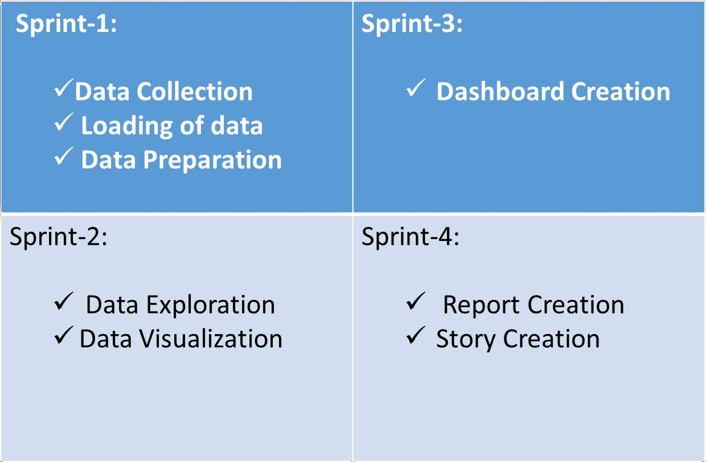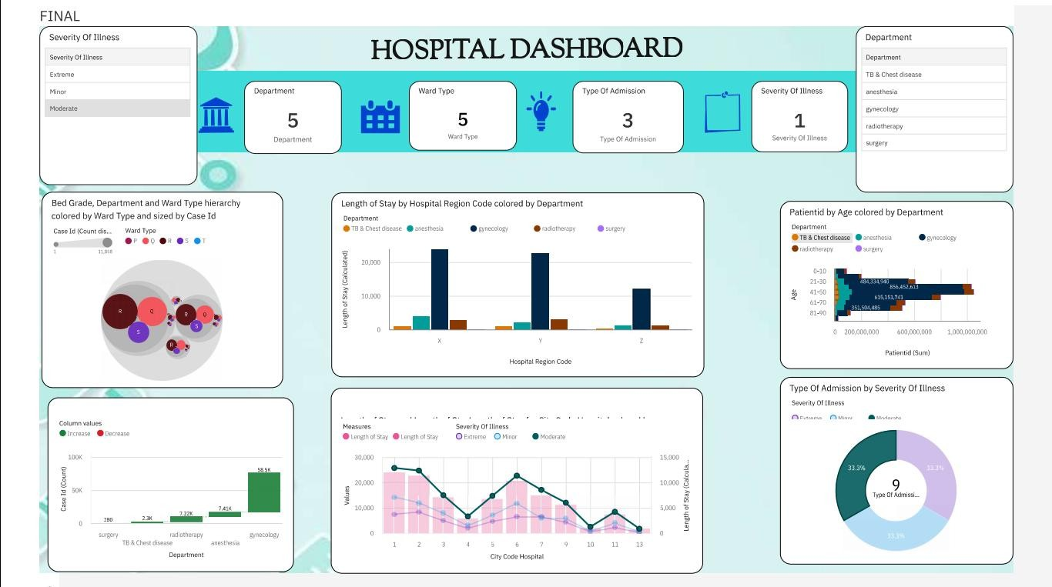

Dash board with the following visuals to present various analytics of Hospitals.

* Bar Chart to showcase number of Cases based on Ward T
* Geo Map to showcase number of cases based on City, Ho

and Region

* Column Chart to showcase Number of Cases by each

Department

* Pie-Chart showcase the Number of Cases by Ward Facilit

type.

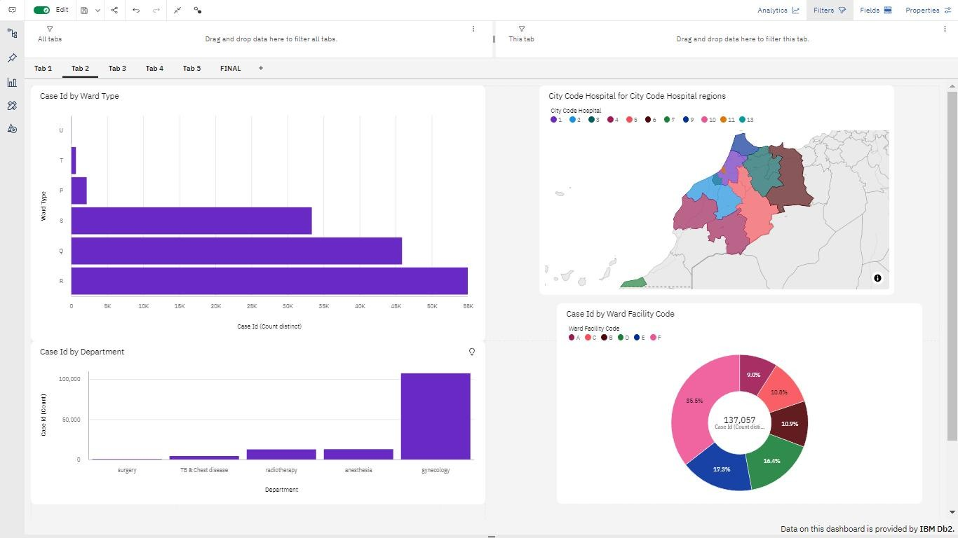

Age wise Number of Patients with Department and Severity Filters.)

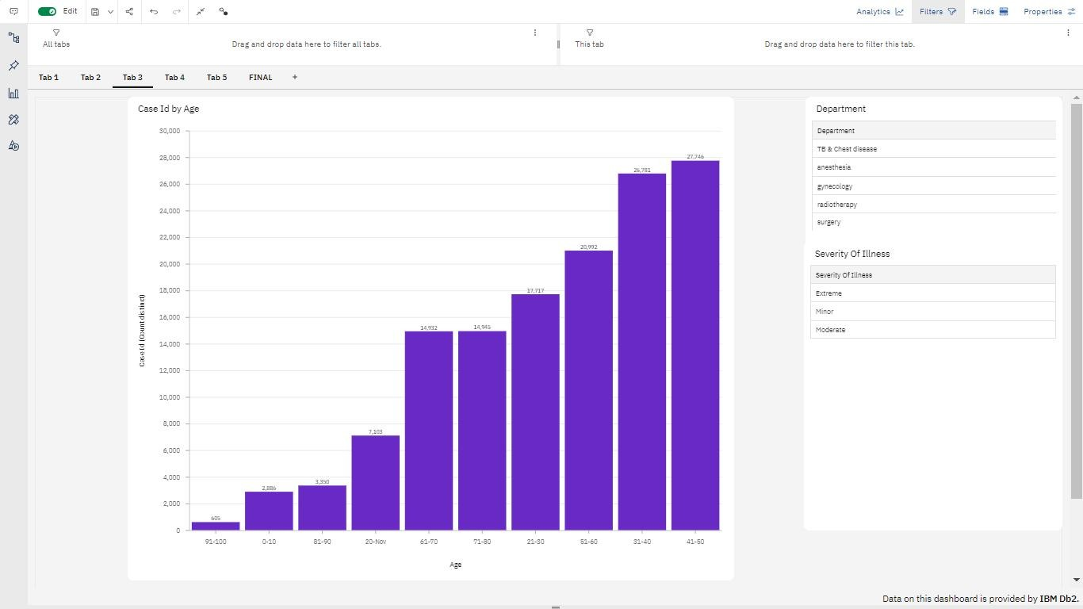

Dashboard with Hierarchy Bubble and Radial Visuals as follows:

* 1. Hierarchy Bubble to show case Bed Grade with Number of Cases by Department and Ward-wise.
  2. Radial chart to show case Department wise Admission Deposit Amount.

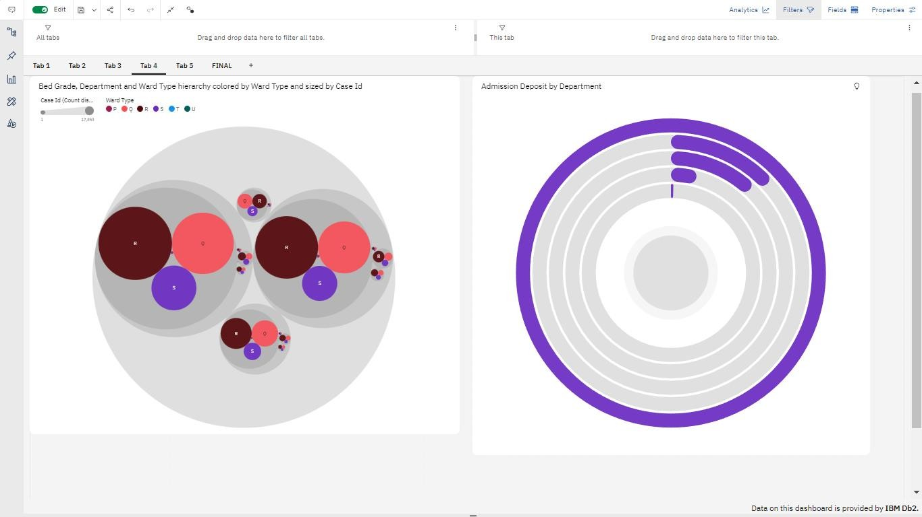

# Dashboard to show case the following analytical visuals.

* + a Pie-Chart showing Severity of illness by

# number of cases.

* + a Stacked Bar Chart to visualize Department- wise, Age-wise number of cases.

# a Waterfall chart visualizing the Department wise number of Patients.

